Excel Assignment - 6

1. What are the various elements of the Excel interface? Describe how they're used.

2. Write down the various applications of Excel in the industry.

3. On the ribbon, make a new tab. Add some different groups, insert commands in the groups and name them according to their commands added. Copy and paste the screenshot of the steps you followed.

4. Make a list of different shortcut keys that are only connected to formatting with their functions.

5. What distinguishes Excel from other analytical tools?

6. Create a table and add a custom header and footer to your table

1. The various elements of the Excel interfaces are

Interface elements and how they are used –

Quick Access toolbar – One click access to any frequently used command.

Name Box -- Displays cell location and can be used to navigate to a cell location.

Select all Button – Select all the cells in a worksheet.

Formula Bar – View, enter or edit cell content.

2. Applications of Excel Budget plan, forecasts, expenses, tracking, financial reports, loan, calculators and more. Excel was pretty much designed.

3. Created new custom tab on ribbon followed the steps for that

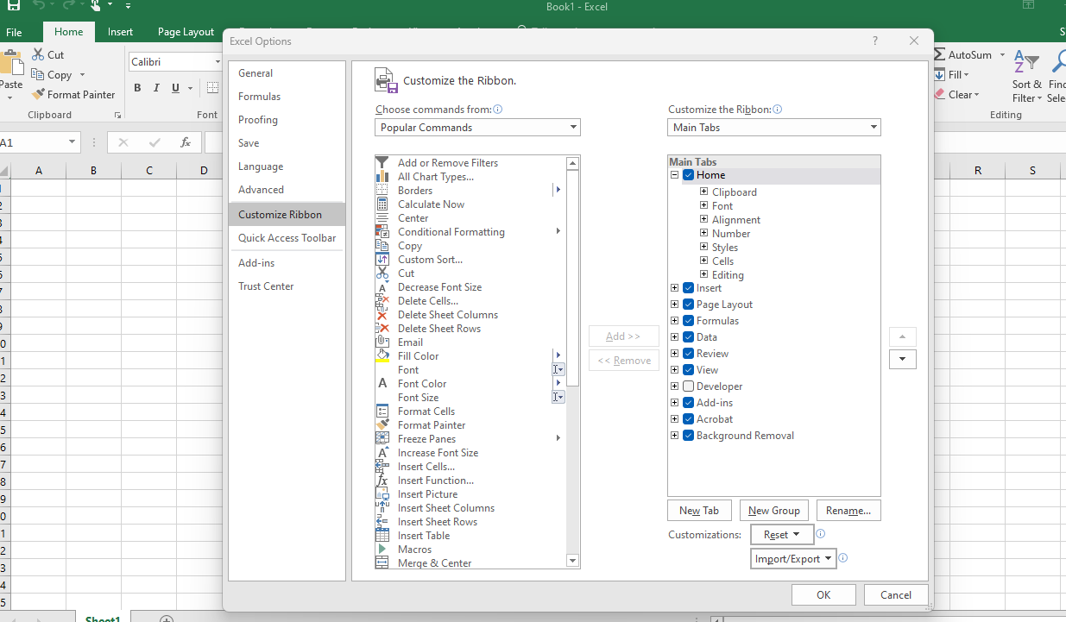

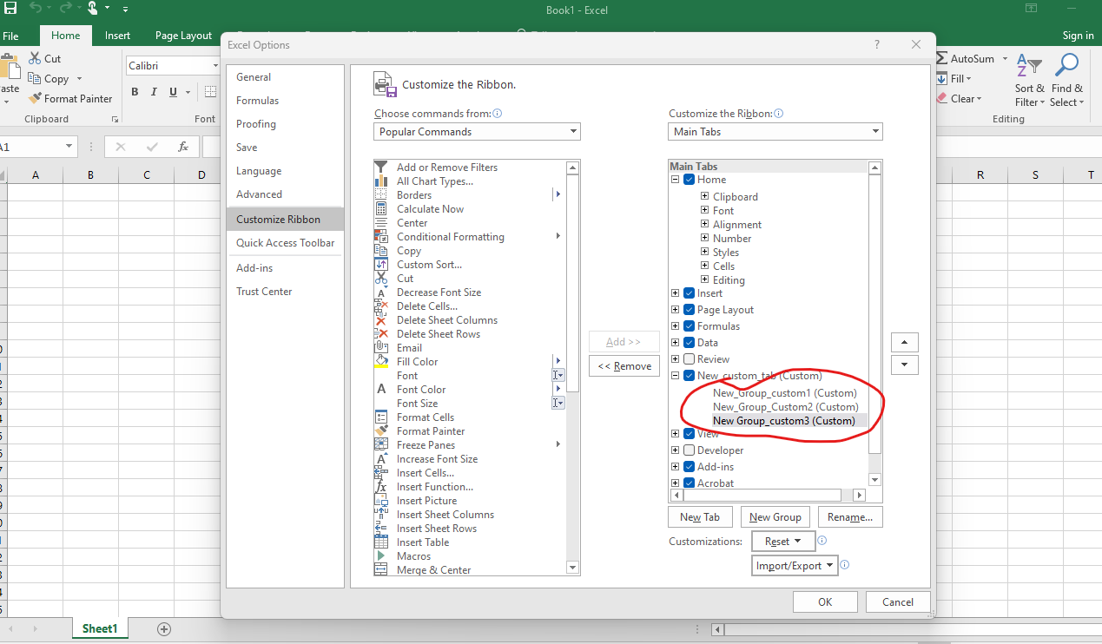

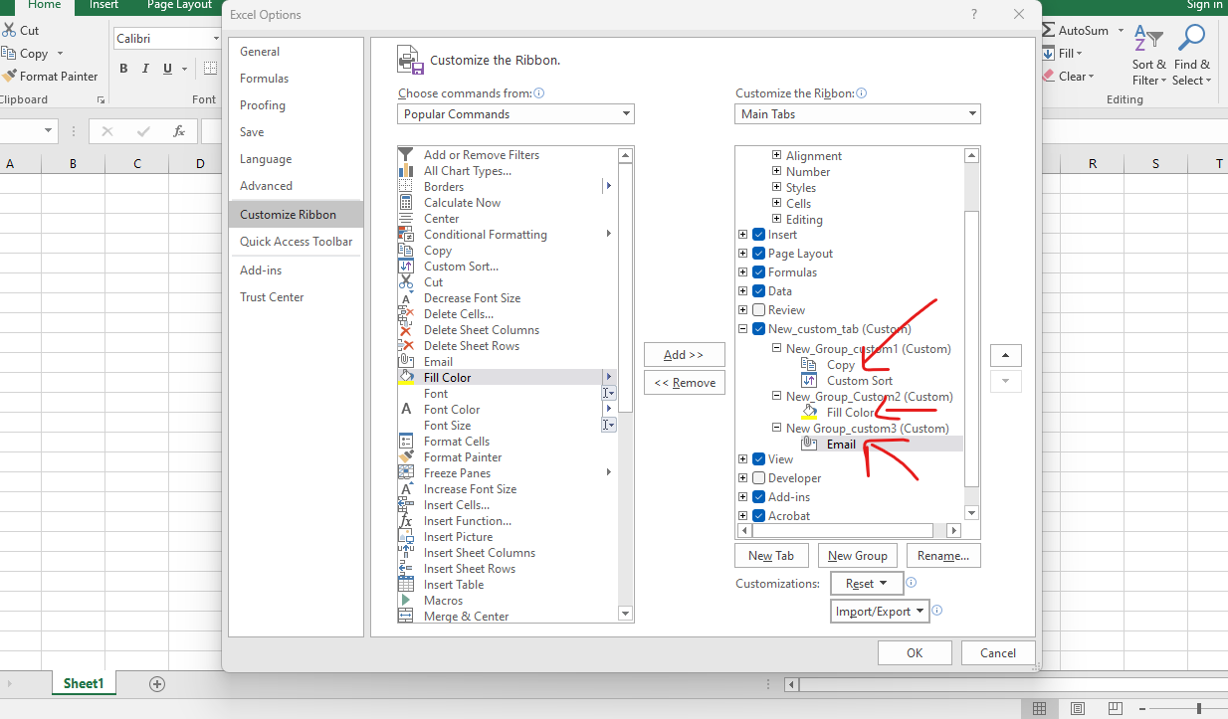

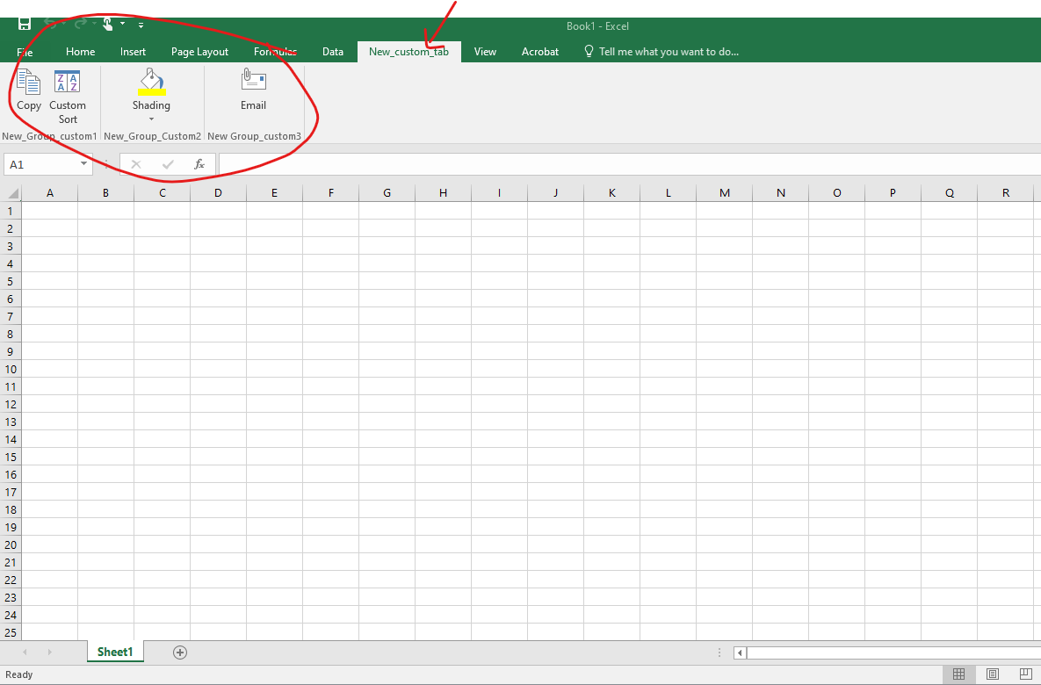

4. Ctrl + R: Aligns the line or selected text to the right of the screen. Ctrl + M: Indent the paragraph. Ctrl + Shift + F: Change the font. Ctrl + Shift + >: Increase selected font +1pts up to 12pt and then increases font +2pts.

5. It provides different color shades, font types to format the spreadsheet and differentiate between rows and columns. It is good to present useful presenting information such as balance, tax profit etc.,

6.

